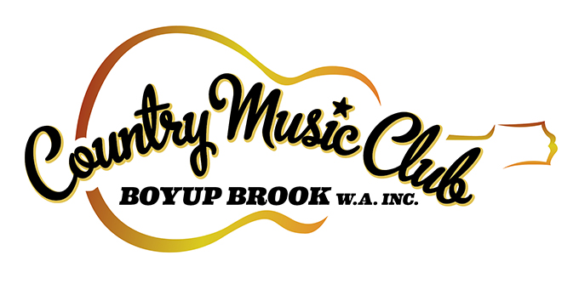

MEMBERSHIP 2021-2022
1st April 2021 – 31st March 2022

- Receive 10% discount on club merchandise and festival tickets
- Receive access to special membership only offers

Personal Details
Full Name
Address
Town |  |  | State |  | Postcode
Email
Contact Number

I would like to receive CMCBB updates by email | Yes |  | No
I would love to volunteer at the Boyup Brook Country Music Festival | Yes |  | No

Annual Membership – Prices includes GST
Membership Type | Amount
Individual | $25.00
Artist | $20.00
Student (proof of student I.D. required) | $10.00

Payment Options
Credit Card | Card Number
 | Visa |  | Mastercard |  |  |  |  |  | CVC |  |  | Expiry Date |  |  |  |  | Amount |  |  | $
 | Cardholders Signature
Direct Deposit | Country Music Club of Boyup Brook WA Inc.  Bendigo Bank – BSB: 633-000 Account #: 160958930
 | Reference: Surname + First initial + Membership
Cheque or Money Order | Made payable to Country Music Club of Boyup Brook WA Inc. |  |  |  |  |  |  |  |  |  |  |  |  |  |  |  | Amount |  |  | $

- All personal information remains confidential and will not be disclosed to any outside bodies without the express consent of the member.

Membership form and cheque payment (if applicable) to be mailed to:

Country Music Club of Boyup Brook WA Inc.
72 Abel St
BOYUP BROOK WA 6244

or email your completed form with payment details to:

hello@wacountrymusic.com.au

